Input Helpers in the NCS

Input Helpers are a way to insert custom functionality into the fields of the NCS metadata editor. When properly configured, a JSP file (containing JSP, HTML, javascript) inserted into the DOM for a particular field, allowing custom functionality. As a simple example, an input helper could display some text in addition to the regular input field. A more complex example would be to hide the original input element for a field, and instead show a custom input widget.

# Configuring an Input Helper

Input Helpers are configured in the Framework Configuration, and use a “path” element. The fields of a path element to be filled include:

* Path – the xpath to this field (e.g., /record/general/my_field)
* Pathname – a human-readable name for this path
* inputHelper – the filepath to the inputHelper file, relative to /editor/input_helpers directory (e.g., lar/my_input_helper.jsp). Note: It is best practice to put Input Helpers for a particular framework in a like-named directory

When properly configured, the input_helper file is physically inserted into HTML DOM for the specified input field (and therefore executed at page load time)

# Your first Input Helper

In the ncs_project directory there is a sample input helper at (dcs-project/web/editor/input_helpers/test/widget.jsp. Create a new directory for your framework, if it doesn’t exist, under input_helpers and copy “widget.jsp” there. Rename the widget file if you wish. (Don’t forget to deploy the input helper file to your tomcat server).

Now configure the input helper for the framework as described above. After modifying the framework configuration you must reload the framework (in this case the “lar” framework) for the modifications to take effect.

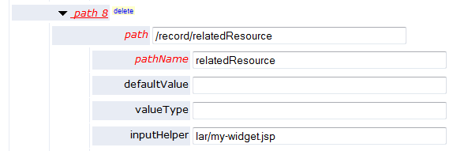

**Configuration of path to receive inputHelper in lar framework**

Now when you open the editor and look at the field you configured for the inputHelper you should see something like this:

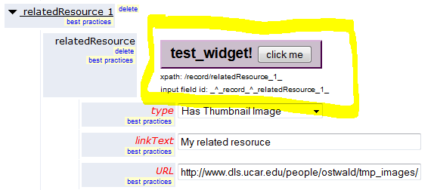

**The /record/relatedResource field with the test Input Helper**

The test_widget demonstrates how variables from the input fields are accessible to the input helper (see xpath). Input fields in the NCS have a DOM ID that is formed by “path-encoding” the xpath to the field’s location in the metadata record.

In the example above, the xpath is /record/relatedResource_1_ and the field ID is _^_record_^_relatedResource_1_. See the widget source for how these fields are accessed.

The Input Helper has access to the entire JSP and javascript context that is available to the Input Helper, and can execute arbitrary code to use the available context.

# More about input helpers

See *FileUploadInput Helper Example* for a more complex example of how to use Input Helpers.